CHAPTER 1

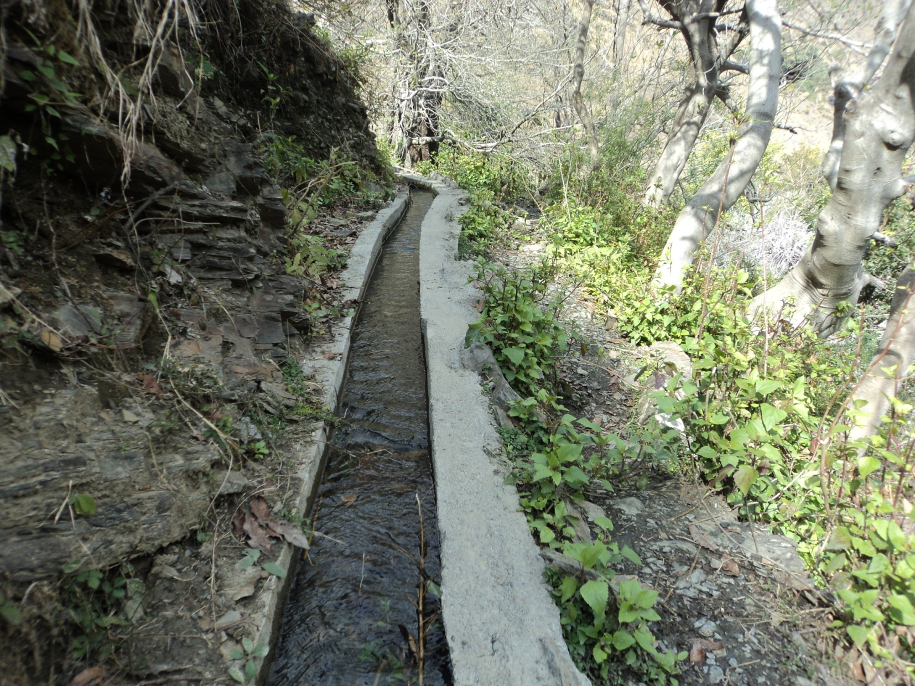

INTRODUCTION

1. **INTRODUCTION**

***1.1. BACKGROUND***

It has been observed that Watershed Projects have been implemented in the state with the objective of management of land and water resources keeping their relationship strong and maintaining the balance between man and environment. These Watershed Projects are being implemented with different names from time to time and have been improvised with the passage of span. Now, Integrated Watershed Management Programme (IWMP), after consolidation of all previous watershed programmes i.e. Drought Prone Area Programme (DPAP, Desert Development Programme (DDP) and Integrated Wasteland Development Programme (IWDP) has been incorporated and is being implemented by Rural Development Department. Different stakeholders are involved in the implementation of the projects. These stakeholders should have a proper understanding and knowledge of the IWMP for effective implementation of the same. So, in order to make the stakeholders understand, the capacity building through trainings, both in-house and off- campus, have to be placed appropriately. H.P. State Institute of Rural Development (HPSIRD) is an Apex Training Institute of the state meant for imparting trainings to different stakeholders on rural development. This *Capacity Building Plan* has been attempted with a view to helping the watershed stakeholders to meet their requirements through training interventions.

It is envisaged that Capacity Building Plan would be useful to the State Level Nodal Agency (SLNA) in providing required professionalism and competence to the stakeholders associated with watershed for effective implementation of IWMP in Himachal Pradesh.

This Plan is intended to provide appropriate knowledge and practical approach to watershed managers and planners, who are involved in watershed survey, planning and execution in watershed projects.

The Capacity Building Plan is primarily aimed at equipping the major stakeholders of Rural Development and Panchayati Raj in order to enable them to understand the concept of watershed, significance of planning, understanding their respective roles in watershed management, the problems, identification of training needs and solutions thereof.

The CB Plan is divided into five major sections. The FIRST section gives an overall *introduction* to the programme (Integrated Watershed Management Programme) and the Institutional Framework. This section also elucidates the roles of these stakeholders during the project implementation. The SECOND section starts with the concept of watershed and the management of watershed. The THIRD section has a discussion part of new common guidelines, showing the role of capacity building. The FOURTH section is focussed on the objectives, importance and process involved in Capacity Building alongwith SWOT analysis. After assessment of the process involved and SWOT Analysis, appropriate training methods have been suggested in FIFTH section of the Plan, including the specific needs of these stakeholders in order to implement the projects effectively.

This document gives an account of stepwise process of different activities to be undertaken during the capacity building interventions under Integrated Watershed Management Programme.

***1.2. INSTITUTIONAL FRAMEWORK***

Para 10 of New Common Guidelines for Watershed Development Projects 2008 (revised edition-2011) recommends following activities form integral part of capacity building strategy:

* Dedicated and decentralised institutional support and delivery mechanism
* Annual Action Plan for Capacity Building
* Pool of resource persons
* Well prepared training modules and reading materials
* Mechanism for effective monitoring and follow-up.

It has been further suggested that NRAA / SLNA may also form Consortium of Resource Organizations to provide necessary capacity building support depending on the need, to the watershed development projects at various levels.

National Level Institution:

NRAA is the support organization at central level. Ministry of Rural Development has recognized the National Institute of Rural Development (NIRD) as the agency to assess and address the capacity building needs throughout the nation or at regional levels.

State Level Institution:

The services of State Level Resource Agencies are being availed to train the state level, district level and block level stakeholders with the appropriate inputs of competent faculty. The existing Institutional Arrangements at state level include the capacity building of Officers from SLNA, WCDCs, PIAs, SHGs, User and Marginalised Groups and ERs of Gram Panchayats/WCs.

District Level Institutional Framework:

The existing Institutional Framework for Capacity Building recommends the capacity building of district level staff/stakeholders through state level Institutions.

However, the services of empanelled agencies could be availed to implement the capacity building plan at district level.

Institutional Framework at Project Level:

The PIA has the responsibility of taking up the capacity building activities and implementing the capacity building plan in the project area. The stakeholders comprise WC/GP members, UG members, SHG members and marginalised groups.

However, the WDT members will be the Resource Persons to build the capacity of stakeholders at village level i.e. WC/GP members, UG, SHG members etc.

The New Common Guidelines recommend a broad Institutional framework and the key activities at each level.

1.2.1. Roles & Responsibilities of the Stakeholders at different level:

The following key responsibilities have been kept in mind while formulating the training modules for different key stakeholders:

1.2.1.**a) Roles & Responsibilities at SLNA/WCDC Level during Preparatory Phase:**

* Selection of watersheds
* Approval of Preliminary Project Report (PPR)
* Selection of PIA
* Deployment of WDT
* Release of funds /state share
* Facilitation to PIAs during DPR preparation
* Approval of Entry Point Activities (EPAs)
* Approval of Detailed Project Report (DPR)
* Selection of Resource Organization

1.2.1. **b) Roles & Responsibilities at SLNA/WCDC Level during Work Phase:**

|  |
| --- |
| * Approval of Annual Action Plans |
| * Release of Funds/Grants to the PIAs |
| * Monitoring & Evaluation |

1.2.1**. c) Roles & Responsibilities at SLNA/WCDC Level during Consolidation Phase:**

|  |
| --- |
| * Evaluation of the projects |
| * Organization of Learning events |
| * Closure of project |

|  |
| --- |
| * User rights policy formulation |

1.2.1. **d) Roles & Responsibilities at PIA/WDT Level during Preparatory Phase:**

|  |
| --- |
| * Rapport building |
| * Capacity building |
| * Entry Point Activities |
| * Watershed delineation |
| * Setting up of benchmarks |
| * DPR preparation |

1.2.1. **e) Roles & Responsibilities at PIA/WDT Level during Work Phase:**

|  |
| --- |
| * Facilitation and provide guidance during execution of works by WCs/GPs |
| * Preparation of ToRs with agencies involved in execution of works |
| * Sanction of works |
| * Facilitation during capacity building programmes |
| * Encouraging the transparency & effectiveness in execution of works |
| * To ensure the women representation and equity during this phase |

1.2.1. **f) Roles & Responsibilities at PIA/WDT Level during Consolidation Phase:**

|  |
| --- |
| * Consolidation of project activities |
| * Preparedness for post project period |
| * To ensure the proper functioning of the institutions promoted for post project management |

1.2.1. **g) Roles & Responsibilities at Community Level during Preparatory Phase:**

|  |
| --- |
| * Capacity building of local community |
| * Situational Analysis |
| * Execution of Entry Point Activities |
| * DPR preparation |

1.2.1. **h) Roles & Responsibilities at Community Level during Work Phase:**

|  |
| --- |
| * Execution of watershed activities as per Annual Action Plan (AAP) |
| * Formation of Self Help Groups & User Groups |
| * Promotion and execution of livelihood activities |
| * Community based monitoring (through monitoring or social audit or gram sabhas) |

1.2.1. **i) Roles & Responsibilities at Community Level during Consolidation Phase:**

|  |
| --- |
| * Completion of activities |
| * Financial part related to project closing |
| * Post project management scenario |

CHAPTER 2

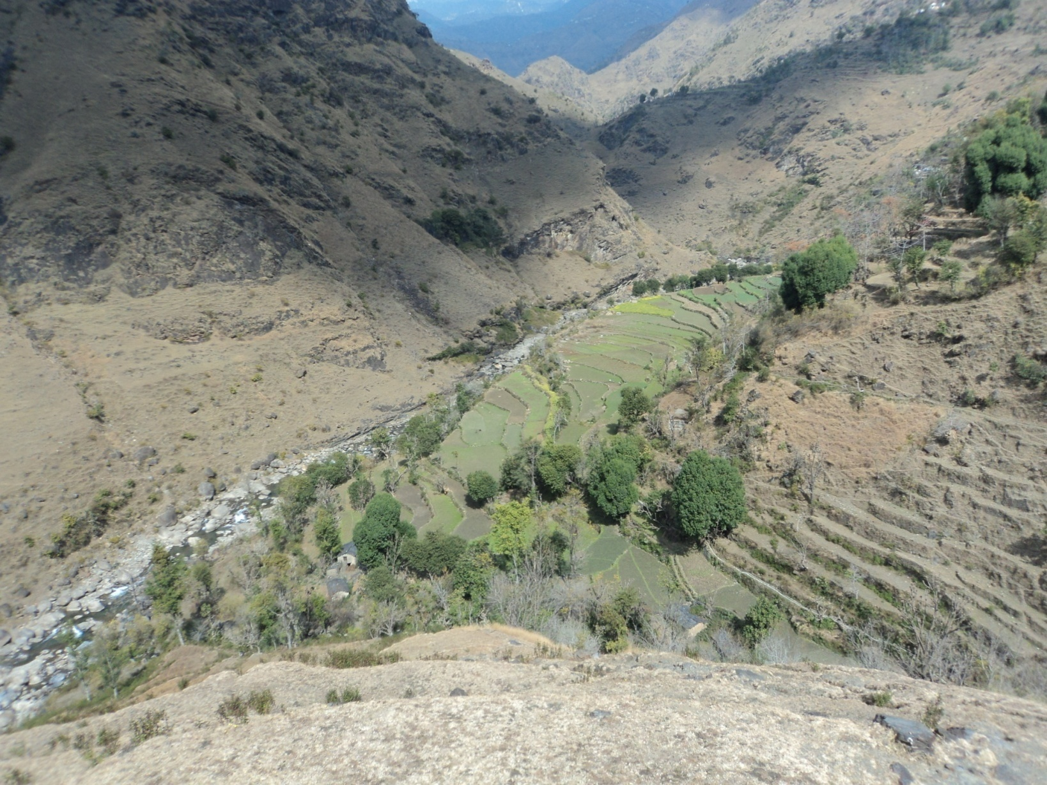

WATERSHED- CONCEPT

**2. WATERSHED -CONCEPT**

**WATERSHED:**

A watershed is a topographically delineated area that is drained by a stream system, i.e. the total land area that is drained to some point on a stream or river.

A watershed is a hydrological unit that has been described and used as a physical-biological unit and also, on many occasions, as a socio-economic-political unit for planning and management of natural resources.

Catchment is often used as a synonym for watershed. There is no definite size for a watershed; it may be as large as several hundred square kilometres or as small as only a few square kilometres.

A watershed is differentiated from a river basin in that a river basin, with its trunk stream flowing to the sea, may encompass hundreds of watersheds and many other types of land formations.

**WATERSHED DEVELOPMENT:**

The aim is to stop and conserve water where it falls, in every watershed area, with the help of Project Implementing Agency i.e. Block Development Office or any other line Department through their Watershed Development Team (WDT) and Watershed Committee (WC) at village level. This water can be used for longer duration.

Watershed development is an approach through a chain of structures/ interventions, which reduces the velocity and volume of runoff. These structures let it walk vertically with very less flow rather than flowing with a high velocity, to avoid any harm to the soil and other biota in that area.

Since rainwater is intervened at regular intervals by watershed structures, it does not flow long distances. It results in:

1. Soil erosion becomes very less, as the momentum of flow of water get reduced.

2. The silt gets deposited in small trenches behind these structures. Thus huge pilling of silt at lowest structure is reduced through this method.

3. With the reduced flow of water, more water percolates into the ground, thus increases the groundwater recharge and hence the water table also get improved.

4. As the flow become very slow, the duration of flow in drainage line increases and it makes water bodies sustainable in that area. The structures made in downstream get refilled after short duration and on continuous basis.

5. The overall biomass will increase with the improvement in soil moisture level.

A typical watershed management programme would comprise of soil conservation, water harvesting, micro irrigation, bio-mass generation, fisheries, animal husbandry, agro processing and micro enterprise components, all properly sequenced.

**WATERSHED MANAGEMENT**:

Watershed management is the process of formulating and carrying out a course of action involving the manipulation of resources in a watershed to provide goods and services without adversely affecting the soil and water base. Usually, watershed management must consider the social, economic and institutional factors operating within and outside the watershed area.

All watersheds contain many kinds of natural resources - soil, water, forest, rangeland, wildlife, minerals, etc. In managing a watershed, the use of some natural resources will be complementary while others will be competitive. For instance, logging may affect water resources and recreation. Changing intensive land use to less intensive ones may benefit soil and water resources. The key is to use these resources as efficiently and perpetually as possible, with minimum disturbance to the watershed as a whole.

CHAPTER 3



NEW COMMON GUIDELINES FOR WATERSHED PROJECT & CAPACITY BUILDING

**3. NEW COMMON GUIDELINES FOR WATERSHED PROJECT & CAPACITY BUILDING**

New Common Guidelines 2008 (revised edition – 2011) stress upon the importance of capacity building at each and every stage of the programme.

***The relevant guiding principles for capacity building are as follows:***

a. Equity and Gender Sensitivity: Watershed Development Projects should be considered as levers of inclusiveness. Project Implementing Agencies must facilitate the equity processes such as 1) enhanced livelihood opportunities for the poor through investment in their assets and improvements in productivity and income, 2) improving access of the poor, especially women to the benefits, 3) enhancing role of women in decision-making processes and their representation in the institutional arrangements and 4) ensuring access to usufruct rights from the common property resources for the resource poor.

b. Decentralization: Project management would improve with decentralization, delegation and professionalism. Establishing suitable institutional arrangements within the overall framework of the Panchayati Raj Institutions, and the operational flexibility in norms to suit varying local conditions will enhance decentralisation. Empowered committees with delegation to rationalise the policies, continuity in administrative support and timely release of funds are the other instruments for effective decentralization.

c. Facilitating Agencies: Social mobilisation, community organisation, building capacities of communities in planning and implementation, ensuring equity arrangements etc need intensive facilitation. Competent organisations including voluntary organizations with professional teams having necessary skills and expertise would be selected through a rigorous process and may be provided financial support to perform the above specific functions.

d. Centrality of Community Participation: Involvement of primary stakeholders is at the centre of planning, budgeting, implementation, and management of watershed projects. Community organizations may be closely associated with and accountable to Gram Sabhas in project activities.

e. Capacity Building and Technology Inputs: Considerable stress would be given on capacity building as a crucial component for achieving the desired results. This would be a continuous process enabling functionaries to enhance their knowledge and skills and develop the correct orientation and perspectives thereby becoming more effective in performing their roles and responsibilities. With current trends and advances in information technology and remote sensing, it is possible to acquire detailed information about the various field level characteristics of any area or region. Thus, the endeavour would be to build in strong technology inputs into the new vision of watershed programmes.

f. Monitoring, Evaluation and Learning: A participatory, outcome and impact-oriented and user-focused Monitoring, Evaluation and Learning system would be put in place to obtain feedback and undertake improvements in planning, project design and implementation.

g. Organizational Restructuring: Establishing appropriate technical and professional support structures at national, state, district and project levels and developing effective functional partnerships among project authorities, implementing agencies and support organizations would play a vital role.

Capacity building support is a crucial component to achieve the desired results from watershed development projects. These Guidelines broadly define the contours of the capacity building strategy for watershed development projects in the country. NRAA would facilitate the evolution of operational strategies for capacity building in each state in consultation with SLNA and other resource organizations. The capacity building strategy and activities enumerated by NRAA, Nodal Agencies at the central level and consortium of resource organizations should be funded separately over and above the earmarked budget for institution and capacity building in the preparatory phase of the watershed development project.

CHAPTER 4

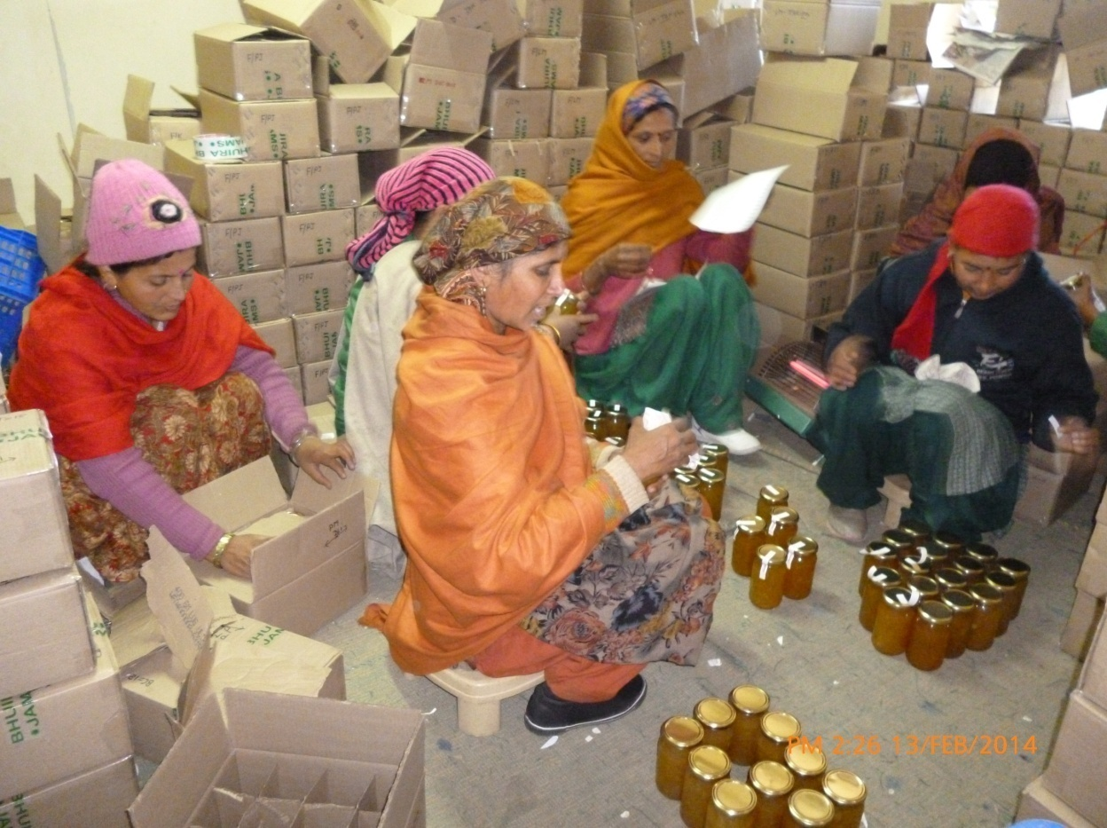

CAPACITY BUILDING

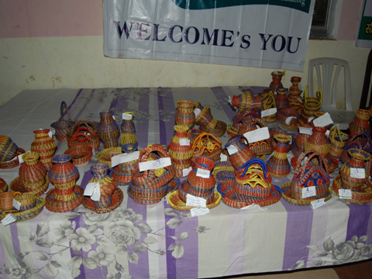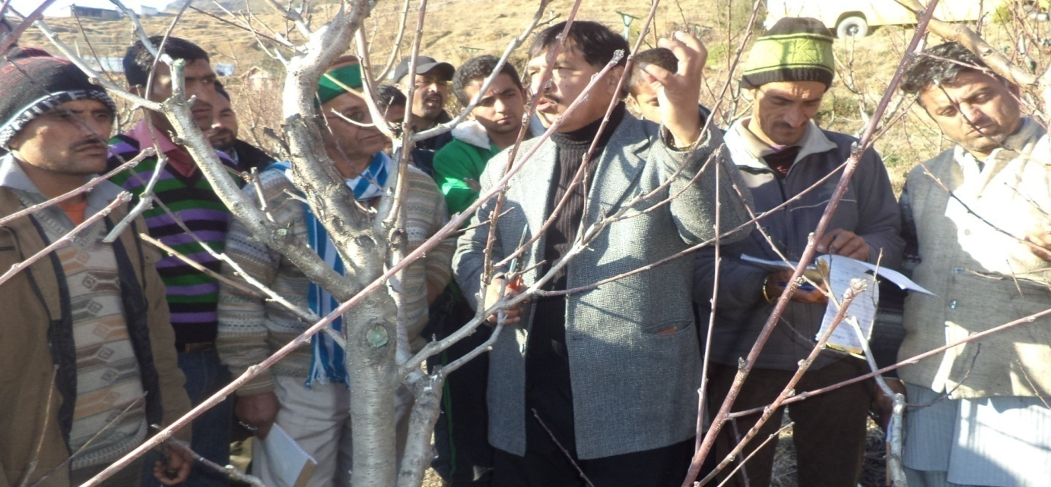

**4. CAPACITY BUILDING**

* 1. ***MEANING:***

Upgrading and strengthening an individual’s or group’s capabilities to manage their works effectively, efficiently, to become self-reliant and sustainable, is the *Capacity Building*.

Major goal of capacity building is to enhance the ability to evaluate and address the programme and modes of implementation among development options, based on an understanding of the potentials and limits and of needs perceived by the stakeholders.

Capacity Building is much more than training and includes:

* Human resource development, the process of equipping individuals with the understanding, skills and access to information, knowledge and training that enables them to perform effectively.
* Organizational development, the elaboration of management structures, processes and procedures, not only within organizations but also the management of relationships between the different organizations and sectors (public, private and community).

(Source: *The Urban Capacity Building Network)*

* 1. ***OBJECTIVES OF CAPACITY BUILDING PLAN IN IWMP:***
* To acquaint the stakeholders with capacity building strategy
* To standardize the process involved during the capacity building programmes
* To identify and classify the modules with respect to the time frame, stakeholders to be trained and methodology to be adopted.
* To enable the planners and administrators involved in IWMP to plan the capacity building programmes in respect of the stakeholders, organizations/Institutes and funds.
* To enable different stakeholders in the project to perform their roles effectively at different stages of the project.
  1. ***EXPECTED OUTCOMES OF CB PLAN:***

1. The mission of watershed project implementation translates the vision of guidelines at the grassroot level.
2. All the stakeholders get the skills to perform their responsibilities they are expected to deliver.
3. Community to be empowered to take the programme forward in a sustainable manner.
   1. ***IMPORTANCE OF CAPACITY BUILDING IN IWMP:***

The rural development needs a holistic approach including every sector to keep the related field growing. In similar fashion, when we consider the watershed development programmes, a real example of holistic approach, of course a scientific, technical and appropriate approach need to be find out. This approach in case of IWMP could be in the form of development of *human resources* especially of the backgrounds like Remote Sensing/GIS, forestry, social sciences, IT, agriculture, animal husbandry, environmental sciences etc. The knowledge of the concept of “Watershed” is a must to every expert of any field but involved in the watershed management. This would definitely enhance the efficiency of their work, so, of the programme as well. Effective Capacity Building (CB) of all stakeholders has become a prerequisite under IWMP to success and sustainability of project outcomes

Thus, a well structured Capacity Building Plan should be put in place to have that understanding of the concept and related management skills.

Every basic step involved in the Integrated Watershed Management Programme (IWMP) needs an extensive use of GIS & Remote Sensing applications at field level to monitor and evaluate the projects. So, well acquainted professionals or project staff needs to be empowered adequately to carry out the activities under IWMP. Hence, these stakeholders need to be trained well.

To really understand the bio-physical environment, drainage pattern, the soil structures incorporation of these with the Remote Sensing, conducting the baseline surveys, PRA exercises, MIS and reporting, the different stakeholders needs different trainings though various modes.

1. **Capacity Building Analysis:**

Based on the training programmes conducted in previous one year and the feedback received from the stakeholders involved, we have come up to the following analysis on capacity building:

* CONCEPT CLARITY: There is a question mark on the concept clarity of watershed. Stakeholders involved have shown a clear gap of basic understanding of the concept.
* ROLE CLARITY: Stakeholders involved, especially WDT members are still not clear about their roles and responsibilities in IWMP. They have certain doubts which need to be cleared at initial stages itself.
* PEOPLE’S PARTICIPATION: Participation of people residing in the watershed area is poor in some cases.
* NON-INTEREST OF EXECUTING AGENCIES: A few PRI members/WC members are showing less interest in the execution of the watershed activities as they have lesser stakes in the programme or may be due to poor knowledge of the programme.

1. **SWOT Analysis:**

**Strengths:**

* Dedicated Institutional Framework
* Resource/ Support Organizations
* Resource Persons/Experts from different fields
* Study material & IEC
* Budget

To put these strengths in a constructive manner to get the desired results, the Capacity Building Plan should be implemented with effective monitoring at every step.

Moreover, we need to find out the prevailing situations in respect of the Weaknesses and Opportunities that exist in the watershed area, which would form a basis to develop the strategy for effective Capacity Building process.

**Weaknesses:**

1. In terms of Resource Organizations:

* Sometimes the Organizations are involved with some other projects at the same time.
* Exposure on community development is not adequate sometimes.

1. Project Implementing Agencies (PIAs):

* The agencies need to build their own capacity on some specific issues related to the programme.
* Due to heavy work pressure, the agencies could not spend the required time on capacity building programmes.

1. Resource Persons/Experts from related Fields:

* The experts are sometimes not available, when required for any specific training programme or exposure visit.
* For a specific category of participants, the pooling of expert on each session becomes tedious, sometimes.

1. Training Material:

* The reading material is sometimes written in English, which could be difficult to understand for few categories of the participants.
* The case studies are not documented in large number.

**Opportunities:**

1. Resource Organizations:

* There are premier organizations which have proved themselves in the category for effective implementation of the programme through community mobilization. The exposure to such organizations needs to be done.
* Different categories may have the access to the new and scientific approach available with the Resource Organizations.
* A list of Resource Organizations is given at the end of the Plan.

1. Project Implementation Agencies:

* These agencies may involve some Voluntary Organizations in Capacity Building process, when required.
* Skill development programmes have to be demand based, which PIA would cater through conduct of such programmes.

1. Resource Persons:

* Experts on various fields like Agriculture, Horticulture, Forestry, Civil Engineering, IT, GIS & RS, Environmental Science, Soil Science are available in and outside the state, who needs to be empanelled.

1. Financial Status:

* Enough budget (5% of the total budget available under project) is available with the PIA for conducting capacity building programmes.
  1. **STRATEGY FOR CAPACITY BUILDING IN THE STATE:**
* **Stakeholders' identification**

Project stakeholders are individuals and organizations that are actively involved in the watershed project, or whose interests may be affected as a result of project execution or project completion. The stakeholders may have direct influence over the project’s objectives and outcomes. We have three types of categories of stakeholders in IWMP:

Primary stakeholders are those who affect the outcome of the project and also get affected by the project.

Secondary stakeholders basically affect the outcome of the project but they are not much affected by the project.

Tertiary stakeholders are those who are affected by the project outcome, but do not affect the project much.

Thus, the training programmes under IWMP are mainly targeted towards the primary stakeholders.

**Stakeholders Involved:**

|  |  |
| --- | --- |
| SLNA | * CEO, SLNA & Team of Experts   Primary   * State Level Officers of line departments |
| WCDC | * Project Officers, WCDC * Team of WCDC (TE, Accountant, DEO etc) * District Level Officers of line departments / Resource Persons   Secondary   * PRIs |
| PIA | * Project Implementing Agencies * 4 member WDT [Engineering (Civil), Agriculture, Animal Husbandry, Social Science & Computer Applications] * Block level officers of line departments / Resource Persons * PRIs   Tertiary |
| Watershed / Village | * Watershed Committee Chairman / Secretary / Other members * SHG Members * Users Group leaders / Members * PRIs * Village Community |

* **CB assessment**

The first and foremost task in the process of Capacity Development is to assess the training requirements of the stakeholders at different levels. • Capacity Building Assessment results in establishing overall Training Objective. • Watershed management being a multidisciplinary approach, it has to address the multi-dimensional needs of all the stakeholders. The training needs and requirements, thrust areas of training, contents and coverage and the project phase during which it is essential to be imparted needs to be assessed for the concerned group of stakeholders.

A kind of test or interview can be conducted with the proposed stakeholder and the results can be used for deciding the way the training is to be done.

**Objectives of CB Assessment:**

1) To decide the nature of training programme

2) To determine the current level of skill and knowledge

3) To know the expectations and psychology of participants

4) To design the training programme appropriately

**Methodology:**

**Assessment of capacity building has been done through following methods:**

* **Observation -** an informal assessment based on observations during the field visits while conducting the evaluation of watershed projects in different watershed areas.
* **Questionnaire method-** A structured questionnaire (trainee specific) was prepared and to filled up by the proposed participants from the fields.
* **Focus Group Discussion and/or Interviews -** The advantage of conducting focused group discussions/interviews is that one will get qualitative feedback from users. This was performed during the training programmes conducted for different stakeholders in previous year.

*All of the above methods have been used for development of capacity building plan.*

* **Resource Organizations**

After conducting the CB need assessment and analyzing the results it is to be decided whether the training can be organised in-house or to be outsourced. The empanelment of the Resource Organizations can be looked after by the SLNA/DWDAs in the state. If the required strength is there, it will be conducted in-house; otherwise one of the pre-identified institutions (list given in Annexure I) is to be selected and be given the task.

Major function of the Resource Organizations:

✓ Develop resource material and modules for capacity building

✓ Develop capacities of „pool of resource person‟ on the given theme as required, through conducting ToT on the above theme.

❖ Provide backstopping support to the Pool of Resource Persons on the given theme

❖ Undertake any action research project (studies, innovations, field level experimentation) in terms of enhancing capacity agenda.

❖ Share the experience, knowledge and learnings with the consortium through participating in the workshops, e-groups and so on.

❖ Comment on the quality, utility and relevance of existing and new modules

❖ Support monitoring, evaluation and learning process with overall impact assessment of Capacity building inputs being supported under the programme.

* **Training Methods:**

The methodology adopted for imparting training or conducting a capacity building programme will be specific to cover the content and need of the participants simultaneously, ensuring the participation of the stakeholders. The different methodologies are categorized as follows:

For imparting training, services of a number of institutions will be taken by the project to fulfil training needs. These resource institutions include Government Institutions, Research Institutes, and Agriculture Universities excelling in their areas of specialization.

Besides, a number of NGOs excelling in integrated participatory watershed management and rural development, additional livelihood opportunities would also be identified to provide training and conduction of exposure visits for the project participant.

For identification of training institutions, following criteria will be taken into consideration:

❖ Adequate experience in handling integrated participatory watershed development projects.

❖ Proven capability of imparting training in integrated participatory watershed planning and management.

❖ Adequate infrastructure support particularly fully equipped classrooms, good library and lodge and board facilities for at least 50 persons.

❖ Faculty with good command on the subject and experience in organising trainings in watershed management including ToT would be shortlisted.

❖ Suitable location for field study visits.

* **ACTION PLAN on Capacity Building of the Stakeholders identified:**

The Capacity Building Action Plan is a planned document including the following details:

* **Action Plan :**

IWMP has the following time frame for every phase as per the suggestive guidelines:

1. Preparatory Phase (1-2 years)
2. Watershed works (2-3 years)
3. Consolidation Phase (1-2 years)

Thus, a plan called Capacity Building Plan for whole projects has been divided into three different areas with timeline i.e. 1st year for Preparatory, 2nd to 4th for Works and 5th for Consolidation.

* To develop training methods

The different training methods have been discussed in Chapter 5.

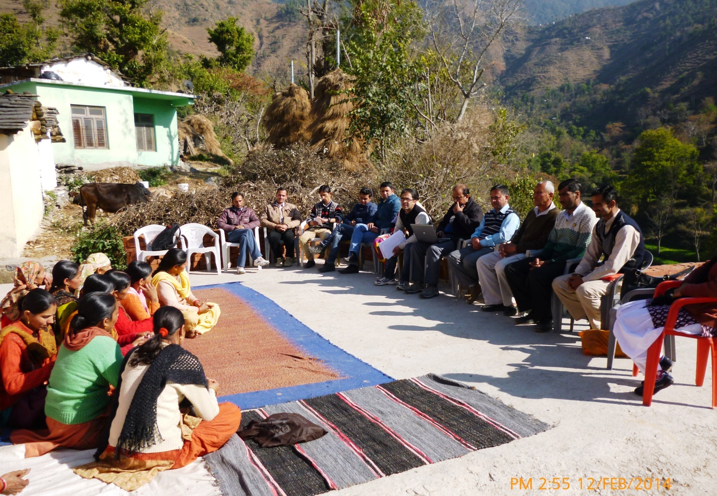

DEVELOPMENT OF MODULES

CHAPTER 5

**5. DEVELOPMENT OF MODULES**

Development of the training modules is the major part of the Capacity Building Plan. It combines all the above discussed parts and put them into sequence alongwith the time frame. Different training modules have been annexure from A-S in this chapter.

**WORKSHOP**

**on**

**IWMP**

**Annexure-A**

**MODULE-I (for PREPARATORY PHASE)**

**Workshop at State Level**

**NAME OF TRAINING PROGRAMME:** IWMP- concept, guidelines & implementation in the state

**TRAINEE:** CEO/PDs/BDOs/WDTMs

**DURATION:** 2 days

**EXPECTED NUMBER OF PARTICIPANTS IN ONE BATCH:** 30

**RESOURCE ORGANIZATION:** HP SIRD Shimla- HIPA

**OBJECTIVE OF THE PROGRAMME:**

* To have the sharing of ideas and understanding of concept, guidelines and other issues of watershed management.
* To explore the programme potential in management of natural resources.
* To get the road map on planning and execution of IWMP.

**TOPICS TO BE COVERED:**

* Concept of New Common Guidelines, Features of watershed, Salient Features of Guidelines
* Planning under IWMP
* Scientific tools for planning
* Case studies of successful watersheds

**BUDGET FOR EACH PROGRAMME:**

**Training duration: 2 (two) days Participants: 30**

|  |  |
| --- | --- |
| **Items/Particulars** | **Total expenditure incurred per programme (Amt. in Rs.)** |
| Boarding/ lodging Charges(per day/per head)  Course Material, Training Kit (including pen, pad and bag), cost of Brochure, training material and Xerox  charges  Training Hall Charges per day including PAS, AV with computer facilities  Miscellaneous (per head per day) Postage, fax, telephones, banner, etc., Group Photo, Honorarium for Guest Speakers, TA for Guest Speaker, Transport cost etc. | Rs. 1350/- x 30 x 2 = Rs. **81000/-** |
| **GRAND TOTAL** | **Rs. 81000/-** |

**Note: The rates/charges mentioned above may have the flexibility of interchangeability, wherever found necessary.**

**TRAINEE SPECIFIC MODULES**

**for**

**TRAINEE: WDT Members**

**(Mixed groups)**

**Annexure-B**

**MODULE-II (for PREPARATORY PHASE)**

**In-House Programmes at State Level**

**NAME OF TRAINING PROGRAMME:** Orientation programme under IWMP

**TRAINEE:** WDT Members

**DURATION:** 6 Days

**TOTAL PARTICIPANTS TO BE TRAINED**: 347 NO’S

**EXPECTED NUMBER OF PARTICIPANTS IN ONE BATCH:** 30

**TENTATIVE NUMBER OF PROGRAMMES TO BE CONDUCTED:** 10 NO’S

**RESOURCE ORGANIZATION:** HP SIRD Shimla/ PSI Dehradun/ Baba Amte Centre for People’s Empowerment Samaj Pragati Sahayog

**OBJECTIVE OF THE PROGRAMME:**

* To familiarize the participants with general concept of watershed and its management.
* To explore the programme potential in management of natural resources.
* To orient the participants/stakeholders towards the community participation.

**TOPICS TO BE COVERED:**

* Concept of New Common Guidelines, Features of watershed, Salient Features of Guidelines
* Concept and techniques of socio-economic survey, Participatory planning, Delineation of watershed, watershed selection, pre-requisites for plan formulation
* Watershed & watershed management, PRA exercise (different methods/tools), Roles and responsibilities of key stakeholders in planning, exposure visits
* Baseline data collection and survey, participatory net planning, methods of technical survey, site selection, DPR formats,
* GIS & RS- concept & definition, Application of GIS & RS in watershed planning, Land Use Land Survey (LULS) Mapping
* Field visit to watershed sites.
* Successful cases under IWMP

**TRAINING METHODS:**

|  |  |  |  |  |
| --- | --- | --- | --- | --- |
| Lecture method  Quiz method, Group activity, Audio-visuals | Group activity, Field visits, training exercises, Audio visuals , case study methods, sharing best practices | PRA exercise, Resource mapping (group activity), field visits/exposure visits, film shows | Presentation method, Group activity, Case study method | Presentation method, Audio-visuals, Hands-on practice |

**BUDGET FOR EACH PROGRAMME:**

**Training duration: 6 (six) days Participants: 30**

|  |  |
| --- | --- |
| **Items/Particulars** | **Total expenditure incurred per programme (Amt. in Rs.)** |
| Lodging Charges(per day/per head) | Rs.1000/- x 6 x 30 = **180000/-** |
| Food Charges:  Breakfast, Lunch, Dinner, Tea and snacks (Per day/ per head) | Rs. 250/- x 6 x 30 = **45000/-** |
| Course Material, Training Kit (including pen, pad and bag), cost of Brochure, training material and Xerox  charges | Rs. 390/- x 30 = **11700/-** |
| Group Photo | Rs. 50/- x 30 = **1500/-** |
| Training Hall Charges per day including PAS, AV with computer facilities | Rs. 4000/- x 6 = **24000/-** |
| Miscellaneous (per head per day) Postage, fax, telephones, banner, etc., | Rs. 50/- x 6 x 30 = **9000/-** |
| Honorarium for Guest Speakers (per day for two sessions) | Rs.800/- x 2 x 5 = **8000/-** |
| Honorarium for Eminent Guest Speakers per session | Rs. 2500/- x 2 = **5000/-** |
| TA for Guest Speaker (maximum upto 100 kms) | Rs. 1000/- x 2 **= 2000/-** |
| Transport cost for local visit | Rs. 150/- x 6 x 30 = **27000/-** |
| Study tour charges | Rs. 150/- x 6 x 30 = **27000/-** |
| **GRAND TOTAL** | **Rs. 3,40,200/-** |

**Note: The rates/charges mentioned above may have the flexibility of interchangeability, wherever found necessary.**

**Annexure-C**

**MODULE-III (for PREPARATORY PHASE)**

**In-House Programmes** at State Level/Outside state

**NAME OF TRAINING PROGRAMME:** Planning under IWMP

**TRAINEE:** WDT Members (mixed groups)

**DURATION:** 3 Days

**TOTAL PARTICIPANTS TO BE TRAINED**: 347 NO’S

**EXPECTED NUMBER OF PARTICIPANTS IN ONE BATCH:** 30

**TENTATIVE NUMBER OF PROGRAMMES TO BE CONDUCTED:** 10 NO’S

**RESOURCE ORGANIZATION:** HP SIRD Shimla/ PSI Dehradun/ Baba Amte Centre for People’s Empowerment Samaj Pragati Sahayog

**OBJECTIVE OF THE PROGRAMME:**

* To familiarize the participants with process of DPR preparation, methodology & other planning processes.
* To explore the techniques of community participation.
* To make the WDT members understand about the basic scientific tools for watershed management.

**TOPICS TO BE COVERED:**

* Concept of Basic Planning.
* Tools & Techniques in W/shed planning.
* PRA exercise (different methods/tools), Roles and responsibilities of key stakeholders in planning, exposure visits
* Baseline data collection and survey, participatory net planning, methods of technical survey, site selection, DPR formats, PPR & DPR Preparation.
* Application of GIS & RS in watershed planning, Land Use Land Survey (LULS) Mapping
* Field visit to watershed sites.

**TRAINING METHODS:**

|  |  |  |
| --- | --- | --- |
| * FGDs * Lecture methods/Presentations * Films on concept of Watershed & watershed management | * PRA exercise in fields * Micro level planning- group activity * Film shows of successful model * Sharing of best practices | * PRA exercise in fields * Micro level planning- group activity * Preparation of Plans- group activity * Lecture methods/Presentations |

**BUDGET FOR EACH PROGRAMME:**

**Training duration: 3 (three) days Participants: 30**

|  |  |
| --- | --- |
| **Items/Particulars** | **Total expenditure incurred per programme (Amt. in Rs.)** |
| Lodging Charges(per day/per head) | Rs.1000/- x 3 x 30 = **90000/-** |
| Food Charges:  Breakfast, Lunch, Dinner, Tea and snacks (Per day/ per head) | Rs. 250/- x 3 x 30 = **22500/-** |
| Course Material, Training Kit (including pen, pad and bag), cost of Brochure, training material and Xerox  charges | Rs. 390/- x 30 = **11700/-** |
| Group Photo | Rs. 50/- x 30 = **1500/-** |
| Training Hall Charges per day including PAS, AV with computer facilities | Rs. 4000/- x 3 = **12000/-** |
| Miscellaneous (per head per day) Postage, fax, telephones, banner, etc., | Rs. 50/- x 3 x 30 = **4500/-** |
| Honorarium for Guest Speakers (per day for two sessions) | Rs.800/- x 2 x 2 = **3200/-** |
| Honorarium for Eminent Guest Speakers per session | Rs. 2500/- x 2 = **5000/-** |
| TA for Guest Speaker (maximum upto 100 kms) | Rs. 1000/- x 2 **= 2000/-** |
| Transport cost for local visit | Rs. 150/- x 3 x 30 = **13500/-** |
| Study tour charges | Rs. 150/- x 6 x 30 = **13500/-** |
| **GRAND TOTAL** | **Rs. 1,79,400/-** |

**Note: The rates/charges mentioned above may have the flexibility of interchangeability, wherever found necessary.**

**TRAINEE SPECIFIC MODULES**

**for**

**TRAINEE: WDT Members**

**(Community Organizers)**

**Annexure-D**

**MODULE-IV (for WORK PHASE)**

**In-House Programmes at State Level/Outside state**

**NAME OF TRAINING PROGRAMME:** Technical training under IWMP

**TRAINEE:** WDT Members (Community organizers)

**DURATION:** 3 Days

**TOTAL PARTICIPANTS TO BE TRAINED**: 95 NO’S (Approx.)

**EXPECTED NUMBER OF PARTICIPANTS IN ONE BATCH:** 30

**TENTATIVE NUMBER OF PROGRAMMES TO BE CONDUCTED:** 3 NO’S

**RESOURCE ORGANIZATION:** HP SIRD Shimla/ PSI Dehradun/ CAPART

**OBJECTIVE OF THE PROGRAMME:**

* To familiarize with the concept of livelihood.
* To map out and analyse the tools for livelihood
* To orient the participants/stakeholders towards the linkages (backward & forward)

**TOPICS TO BE COVERED:**

* Livelihoods- basic concept, framework & local economy
* Mapping & Analysis tools for Livelihoods
* Enterprises for livelihood
* Backward & forward linkages in livelihood enhancement system
* Fund management system (Revolving fund/financing in livelihoods)
* Feasibility, viability & cost-effectiveness
* Livelihood cycle
* Farm based livelihood options
* Off-farm livelihood options
* Permissible livelihoods under IWMP
* Role of IWMP in taking up the promotion of livelihoods & its relation
* Participatory development of watershed area & livelihoods

**TRAINING METHODS:**

|  |  |
| --- | --- |
| * Flip chart methods/ group activity * FGDs * Exposure visit to a model watershed/site * Films/documentaries * Experience sharing with experts | * Flip chart methods/ group activity * FGDs * Exposure visit to a model watershed/site * Films/documentaries * Experience sharing with experts |

**BUDGET FOR EACH PROGRAMME:**

**Training duration: 3 (three) days Participants: 30**

|  |  |
| --- | --- |
| **Items/Particulars** | **Total expenditure incurred per programme (Amt. in Rs.)** |
| Lodging Charges(per day/per head) | Rs.1000/- x 3 x 30 = **90000/-** |
| Food Charges:  Breakfast, Lunch, Dinner, Tea and snacks (Per day/ per head) | Rs. 250/- x 3 x 30 = **22500/-** |
| Course Material, Training Kit (including pen, pad and bag), cost of Brochure, training material and Xerox  charges | Rs. 390/- x 30 = **11700/-** |
| Group Photo | Rs. 50/- x 30 = **1500/-** |
| Training Hall Charges per day including PAS, AV with computer facilities | Rs. 4000/- x 3 = **12000/-** |
| Miscellaneous (per head per day) Postage, fax, telephones, banner, etc., | Rs. 50/- x 3 x 30 = **4500/-** |
| Honorarium for Guest Speakers (per day for two sessions) | Rs.800/- x 2 x 2 = **3200/-** |
| Honorarium for Eminent Guest Speakers per session | Rs. 2500/- x 2 = **5000/-** |
| TA for Guest Speaker (maximum upto 100 kms) | Rs. 1000/- x 2 **= 2000/-** |
| Transport cost for local visit | Rs. 150/- x 3 x 30 = **13500/-** |
| Study tour charges | Rs. 150/- x 6 x 30 = **13500/-** |
| **GRAND TOTAL** | **Rs. 1,79,400/-** |

**Note: The rates/charges mentioned above may have the flexibility of interchangeability, wherever found necessary.**

**TRAINEE SPECIFIC MODULES**

**for**

**TRAINEE: WDT Members**

**(WDT civil)**

**Annexure-E**

**MODULE-V (for WORK PHASE)**

**In-House Programmes at State Level/Outside state**

**NAME OF TRAINING PROGRAMME:** Technical training under IWMP

**TRAINEE:** WDT Members (Civil)

**DURATION:** 3 Days

**TOTAL PARTICIPANTS TO BE TRAINED**: 96 NO’S (Approx.)

**EXPECTED NUMBER OF PARTICIPANTS IN ONE BATCH:** 30

**TENTATIVE NUMBER OF PROGRAMMES TO BE CONDUCTED:** 3 NO’S

**RESOURCE ORGANIZATION:** HP SIRD Shimla / CAPART/CSWRTI

**OBJECTIVE OF THE PROGRAMME:**

* To familiarize the participants with ‘knowhow’ of the technical interventions in watershed projects.
* To make the participants understand the balance of soil and water.
* To facilitate the participants in making good technical interventions with incorporation of low cost technologies.

**TOPICS TO BE COVERED:**

* What is a treatment plan,
* the problem solving approaches,
* Understanding the nature of soil & water,
* Formulation of treatment plan, Execution of treatment plan
* Basics of Geomorphology, hydrology & soil-science,
* different techniques of Soil Moisture Conservation,
* Low cost technologies for watershed management.

**TRAINING METHODS:**

|  |  |  |  |
| --- | --- | --- | --- |
| * Lecture method/presentation * Group activity * FGDs * Audio-visuals | * Presentation method (technical sessions) * Film shows * Sharing best practices * Live demonstrations * Case study methods | * Presentation method (technical sessions) * Film shows * Sharing best practices * Live demonstrations * Case study methods * Exposure visits | * Presentation method (technical sessions) * Film shows * Sharing best practices * Live demonstrations * Case study methods * Exposure visits |

**BUDGET FOR EACH PROGRAMME:**

**Training duration: 3 (three) days Participants: 30**

|  |  |
| --- | --- |
| **Items/Particulars** | **Total expenditure incurred per programme (Amt. in Rs.)** |
| Lodging Charges(per day/per head) | Rs.1000/- x 3 x 30 = **90000/-** |
| Food Charges:  Breakfast, Lunch, Dinner, Tea and snacks (Per day/ per head) | Rs. 250/- x 3 x 30 = **22500/-** |
| Course Material, Training Kit (including pen, pad and bag), cost of Brochure, training material and Xerox  charges | Rs. 390/- x 30 = **11700/-** |
| Group Photo | Rs. 50/- x 30 = **1500/-** |
| Training Hall Charges per day including PAS, AV with computer facilities | Rs. 4000/- x 3 = **12000/-** |
| Miscellaneous (per head per day) Postage, fax, telephones, banner, etc., | Rs. 50/- x 3 x 30 = **4500/-** |
| Honorarium for Guest Speakers (per day for two sessions) | Rs.800/- x 2 x 2 = **3200/-** |
| Honorarium for Eminent Guest Speakers per session | Rs. 2500/- x 2 = **5000/-** |
| TA for Guest Speaker (maximum upto 100 kms) | Rs. 1000/- x 2 **= 2000/-** |
| Transport cost for local visit | Rs. 150/- x 3 x 30 = **13500/-** |
| Study tour charges | Rs. 150/- x 6 x 30 = **13500/-** |
| **GRAND TOTAL** | **Rs. 1,79,400/-** |

**Note: The rates/charges mentioned above may have the flexibility of interchangeability, wherever found necessary.**

**TRAINEE SPECIFIC MODULES**

**for**

**TRAINEE: WDT Members**

**(Agri./Horti./Forestry)**

**Annexure-F**

**MODULE-VI (for WORK PHASE)**

**In-House Programmes at State Level/Outside state**

**NAME OF TRAINING PROGRAMME:** Technical training under IWMP

**TRAINEE:** WDT Members (Agri./Horti./Forestry)

**DURATION:** 3 Days

**TOTAL PARTICIPANTS TO BE TRAINED**: 94 NO’S (Approx.)

**EXPECTED NUMBER OF PARTICIPANTS IN ONE BATCH:** 30

**TENTATIVE NUMBER OF PROGRAMMES TO BE CONDUCTED:** 3 NO’S

**RESOURCE ORGANIZATION:** HP SIRD Shimla / CAPART/CSWRTI

**OBJECTIVE OF THE PROGRAMME:**

* To familiarize the participants with ‘knowhow’ of the technical interventions in watershed projects.
* To make the participants understand the balance of soil and water.
* To facilitate the participants in making good technical interventions w.r.t. the production system.

**TOPICS TO BE COVERED:**

* Drainage system, Water budget, Low cost tech. & structural aspects in Watershed management, Participatory irrigation system, Natural Resource Management-the concept & Benefit sharing
* Farming system-conventional & new, innovative techniques in farming system, Relation between watershed management & agriculture/horticulture/forests sectors

**TRAINING METHODS:**

|  |  |
| --- | --- |
| * Group activity * FGDs * Exposure visit to a model village & field demonstrations * Films/documentaries * Experience sharing with experts through presentations | * Flip chart methods/ group activity * FGDs * Exposure visit to a model village & field demonstrations * Films/documentaries * Experience sharing with experts through presentations |

**BUDGET FOR EACH PROGRAMME:**

**Training duration: 3 (three) days Participants: 30**

|  |  |
| --- | --- |
| **Items/Particulars** | **Total expenditure incurred per programme (Amt. in Rs.)** |
| Lodging Charges(per day/per head) | Rs.1000/- x 3 x 30 = **90000/-** |
| Food Charges:  Breakfast, Lunch, Dinner, Tea and snacks (Per day/ per head) | Rs. 250/- x 3 x 30 = **22500/-** |
| Course Material, Training Kit (including pen, pad and bag), cost of Brochure, training material and Xerox  charges | Rs. 390/- x 30 = **11700/-** |
| Group Photo | Rs. 50/- x 30 = **1500/-** |
| Training Hall Charges per day including PAS, AV with computer facilities | Rs. 4000/- x 3 = **12000/-** |
| Miscellaneous (per head per day) Postage, fax, telephones, banner, etc., | Rs. 50/- x 3 x 30 = **4500/-** |
| Honorarium for Guest Speakers (per day for two sessions) | Rs.800/- x 2 x 2 = **3200/-** |
| Honorarium for Eminent Guest Speakers per session | Rs. 2500/- x 2 = **5000/-** |
| TA for Guest Speaker (maximum upto 100 kms) | Rs. 1000/- x 2 **= 2000/-** |
| Transport cost for local visit | Rs. 150/- x 3 x 30 = **13500/-** |
| Study tour charges | Rs. 150/- x 6 x 30 = **13500/-** |
| **GRAND TOTAL** | **Rs. 1,79,400/-** |

**Note: The rates/charges mentioned above may have the flexibility of interchangeability, wherever found necessary.**

**TRAINEE SPECIFIC MODULES**

**for**

**TRAINEE: WDT Members**

**(DEOs)**

**Annexure-G**

**MODULE-VII (for WORK PHASE)**

**In-House Programmes at State Level/Outside state**

**NAME OF TRAINING PROGRAMME:** Technical training under IWMP

**TRAINEE:** WDT Members (DEOs)

**DURATION:** 3 Days

**TOTAL PARTICIPANTS TO BE TRAINED**: 62 NO’S (Approx.)

**EXPECTED NUMBER OF PARTICIPANTS IN ONE BATCH:** 30

**TENTATIVE NUMBER OF PROGRAMMES TO BE CONDUCTED:** 2 NO’S

**RESOURCE ORGANIZATION:** HP SIRD Shimla / SLNA

**OBJECTIVE OF THE PROGRAMME:**

* To get the participants fully aware of the MIS management-the concept & idea.
* To have the understanding of various formats used under IWMP.
* To have the hands-on sessions to make the participants acquainted with MIS tool.

**TOPICS TO BE COVERED:**

* Discussion on MIS formats
* Report generation in MIS
* Review & reporting system (MPR, QPR, AAP)
* MIS software
* Issues related to freezing & unfreezing the data
* Basic understanding of data entry
* Role of ICT in watershed management
* Various web based approaches for WM
* Problem solving approaches.

**TRAINING METHODS:**

|  |  |  |  |
| --- | --- | --- | --- |
| * Lecture method/presentation * Group activity * FGDs * Audio-visuals | * Presentation method (technical sessions) * Film shows * Sharing best practices * Case study methods | * Presentation method (technical sessions) * Short films * Hands-on (practical sessions) * Software on DEAS | * Presentation method (technical sessions) * Short films * Hands-on (practical sessions) |

**BUDGET FOR EACH PROGRAMME:**

**Training duration: 3 (three) days Participants: 30**

|  |  |
| --- | --- |
| **Items/Particulars** | **Total expenditure incurred per programme (Amt. in Rs.)** |
| Lodging Charges(per day/per head) | Rs.1000/- x 3 x 30 = **90000/-** |
| Food Charges:  Breakfast, Lunch, Dinner, Tea and snacks (Per day/ per head) | Rs. 250/- x 3 x 30 = **22500/-** |
| Course Material, Training Kit (including pen, pad and bag), cost of Brochure, training material and Xerox  charges | Rs. 390/- x 30 = **11700/-** |
| Group Photo | Rs. 50/- x 30 = **1500/-** |
| Training Hall Charges per day including PAS, AV with computer facilities | Rs. 4000/- x 3 = **12000/-** |
| Miscellaneous (per head per day) Postage, fax, telephones, banner, etc., | Rs. 50/- x 3 x 30 = **4500/-** |
| Honorarium for Guest Speakers (per day for two sessions) | Rs.800/- x 2 x 2 = **3200/-** |
| Honorarium for Eminent Guest Speakers per session | Rs. 2500/- x 2 = **5000/-** |
| TA for Guest Speaker (maximum upto 100 kms) | Rs. 1000/- x 2 **= 2000/-** |
| Transport cost for local visit | Rs. 150/- x 3 x 30 = **13500/-** |
| Study tour charges | Rs. 150/- x 6 x 30 = **13500/-** |
| **GRAND TOTAL** | **Rs. 1,79,400/-** |

**Note: The rates/charges mentioned above may have the flexibility of interchangeability, wherever found necessary.**

**TRAINEE SPECIFIC MODULES**

**for**

**TRAINEE: WDT Members**

**(Mixed groups)**

**TRAINEE SPECIFIC MODULES**

**for**

1. **PRI Representatives**
2. **SHG Members**
3. **UG Members**

**Annexure-H**

**MODULE-VIII (for PREPARATORY PHASE)**

**In-House Programmes at State Level**

**NAME OF TRAINING PROGRAMME:** Orientation programme under IWMP

**TRAINEE:** PRI Members

**DURATION:** 6 Days

**TOTAL PARTICIPANTS TO BE TRAINED**: 14000 NO’S

**EXPECTED NUMBER OF PARTICIPANTS IN ONE BATCH:** 30

**TENTATIVE NUMBER OF PROGRAMMES TO BE CONDUCTED:** 467 NO’S

**RESOURCE ORGANIZATION:** PSI Dehradun/ Baba Amte Centre for People’s Empowerment Samaj Pragati Sahayog/CSWRTI/HPSIRD

**OBJECTIVE OF THE PROGRAMME:**

* To familiarize the participants with general concept of watershed and its management.
* To explore the programme potential in management of natural resources.
* To orient the participants/stakeholders towards the community participation.

**TOPICS TO BE COVERED:**

* Concept of New Common Guidelines, Features of watershed, Salient Features of Guidelines
* Concept and techniques of socio-economic survey, Participatory planning, Delineation of watershed, watershed selection, pre-requisites for plan formulation
* Watershed & watershed management, PRA exercise (different methods/tools), Roles and responsibilities of key stakeholders in planning, exposure visits
* Baseline data collection and survey, participatory net planning, methods of technical survey, site selection, DPR formats,
* GIS & RS- concept & definition, Application of GIS & RS in watershed planning, Land Use Land Survey (LULS) Mapping
* Field visit to watershed sites.
* Successful cases under IWMP

**TRAINING METHODS:**

|  |  |  |  |  |
| --- | --- | --- | --- | --- |
| Lecture method  Quiz method, Group activity, Audio-visuals | Group activity, Field visits, training exercises, Audio visuals , case study methods, sharing best practices | PRA exercise, Resource mapping (group activity), field visits/exposure visits, film shows | Presentation method, Group activity, Case study method | Presentation method, Audio-visuals, Hands-on practice |

**BUDGET FOR EACH PROGRAMME:**

**Training duration: 6 (six) days Participants: 30**

|  |  |
| --- | --- |
| **Items/Particulars** | **Total expenditure incurred per programme (Amt. in Rs.)** |
| Lodging Charges(per day/per head) | Rs.1000/- x 6 x 30 = **180000/-** |
| Food Charges:  Breakfast, Lunch, Dinner, Tea and snacks (Per day/ per head) | Rs. 250/- x 6 x 30 = **45000/-** |
| Course Material, Training Kit (including pen, pad and bag), cost of Brochure, training material and Xerox  charges | Rs. 390/- x 30 = **11700/-** |
| Group Photo | Rs. 50/- x 30 = **1500/-** |
| Training Hall Charges per day including PAS, AV with computer facilities | Rs. 4000/- x 6 = **24000/-** |
| Miscellaneous (per head per day) Postage, fax, telephones, banner, etc., | Rs. 50/- x 6 x 30 = **9000/-** |
| Honorarium for Guest Speakers (per day for two sessions) | Rs.800/- x 2 x 5 = **8000/-** |
| Honorarium for Eminent Guest Speakers per session | Rs. 2500/- x 2 = **5000/-** |
| TA for Guest Speaker (maximum upto 100 kms) | Rs. 1000/- x 2 **= 2000/-** |
| Transport cost for local visit | Rs. 150/- x 6 x 30 = **27000/-** |
| Study tour charges | Rs. 150/- x 6 x 30 = **27000/-** |
| **GRAND TOTAL** | **Rs. 3,40,200/-** |

**Note: The rates/charges mentioned above may have the flexibility of interchangeability, wherever found necessary.**

**Annexure-I**

**MODULE-IX (for WORK PHASE)**

**In-House Programmes** at Project/Block Level

**NAME OF TRAINING PROGRAMME:** Technical Training under IWMP

**TRAINEE:** PRI members

**DURATION:** 3 Days

**TOTAL PARTICIPANTS TO BE TRAINED**: 14000 NO’S

**EXPECTED NUMBER OF PARTICIPANTS IN ONE BATCH:** 30

**TENTATIVE NUMBER OF PROGRAMMES TO BE CONDUCTED:** 467 NO’S

**RESOURCE ORGANIZATION:** PSI Dehradun/ Baba Amte Centre for People’s Empowerment Samaj Pragati Sahayog/CSWRTI

**OBJECTIVE OF THE PROGRAMME:**

* To familiarize the participants with process of DPR preparation, methodology & other planning processes.
* To explore the techniques of community participation.
* To make the WDT members understand about the basic scientific tools for watershed management.

**TOPICS TO BE COVERED:**

* What is a treatment plan,
* the problem solving approaches,
* Understanding the nature of soil & water,
* Formulation of treatment plan, Execution of treatment plan
* Basics of Geomorphology, hydrology & soil-science,
* different techniques of Soil Moisture Conservation,
* Low cost technologies for watershed management.

**TRAINING METHOD:**

|  |  |  |  |
| --- | --- | --- | --- |
| * Lecture method/presentation * Group activity * FGDs * Audio-visuals | * Presentation method (technical sessions) * Film shows * Sharing best practices * Live demonstrations * Case study methods | * Presentation method (technical sessions) * Film shows * Sharing best practices * Live demonstrations * Case study methods * Exposure visits | * Presentation method (technical sessions) * Film shows * Sharing best practices * Live demonstrations * Case study methods * Exposure visits |

**BUDGET FOR EACH PROGRAMME:**

**Training duration: 3 (three) days Participants: 30**

|  |  |
| --- | --- |
| **Items/Particulars** | **Total expenditure incurred per programme (Amt. in Rs.)** |
| Lodging Charges(per day/per head) | Rs.300/- x 3 x 30 = **27000/-** |
| Food Charges:  Breakfast, Lunch, Dinner, Tea and snacks (Per day/ per head) | Rs. 150/- x 3 x 30 = **13500/-** |
| Course Material, Training Kit (including pen, pad and bag), cost of Brochure, training material and Xerox  charges | Rs. 390/- x 30 = **11700/-** |
| Group Photo | Rs. 50/- x 30 = **1500/-** |
| Training Hall Charges per day including PAS, AV with computer facilities | Rs. 2100/- x 3 = **6300/-** |
| Miscellaneous (per head per day) Postage, fax, telephones, banner, etc., | Rs. 50/- x 3 x 30 = **4500/-** |
| Honorarium for Guest Speakers (per day for two sessions) | Rs.500/- x 2 x 3 = **3000/-** |
| TA for Guest Speaker (maximum upto 100 kms) | Rs. 800/- x 2 **= 1600/-** |
| Transport cost for local visit | Rs. 100/- x 3 x 30 = **9000/-** |
| Study tour charges | Rs. 100/- x 3 x 30 = **9000/-** |
| **GRAND TOTAL** | **Rs. 87,100/-** |

**Note: The rates/charges mentioned above may have the flexibility of interchangeability, wherever found necessary.**

**Annexure-J**

**MODULE-X (for WORK PHASE)**

**In-House Programmes at State Level/Outside state**

**NAME OF TRAINING PROGRAMME:** Livelihood under IWMP

**TRAINEE:** PRI Members

**DURATION:** 3 Days

**TOTAL PARTICIPANTS TO BE TRAINED**: 14000 NO’S

**EXPECTED NUMBER OF PARTICIPANTS IN ONE BATCH:** 30

**TENTATIVE NUMBER OF PROGRAMMES TO BE CONDUCTED:** 467 NO’S (Approx.)

**RESOURCE ORGANIZATION:** HIMCON/PSI Dehradun/CAPART

**OBJECTIVE OF THE PROGRAMME:**

* To familiarize with the concept of livelihood.
* To map out and analyse the tools for livelihood
* To orient the participants/stakeholders towards the linkages (backward & forward)

**TOPICS TO BE COVERED:**

* Livelihoods- basic concept, framework & local economy
* Mapping & Analysis tools for Livelihoods
* Enterprises for livelihood
* Backward & forward linkages in livelihood enhancement system
* Fund management system (Revolving fund/financing in livelihoods)
* Feasibility, viability & cost-effectiveness
* Livelihood cycle
* Farm based livelihood options
* Off-farm livelihood options
* Permissible livelihoods under IWMP
* Role of IWMP in taking up the promotion of livelihoods & its relation
* Participatory development of watershed area & livelihoods

**TRAINING METHODS:**

|  |  |
| --- | --- |
| * Flip chart methods/ group activity * FGDs * Exposure visit to a model watershed/site * Films/documentaries * Experience sharing with experts/practitioner | * Group activity * FGDs * Exposure visit to a model watershed/site * Films/documentaries * Experience sharing with experts * Practical sessions |

**BUDGET FOR EACH PROGRAMME:**

**Training duration: 3 (three) days Participants: 30**

|  |  |
| --- | --- |
| **Items/Particulars** | **Total expenditure incurred per programme (Amt. in Rs.)** |
| Lodging Charges(per day/per head) | Rs.1000/- x 3 x 30 = **90000/-** |
| Food Charges:  Breakfast, Lunch, Dinner, Tea and snacks (Per day/ per head) | Rs. 250/- x 3 x 30 = **22500/-** |
| Course Material, Training Kit (including pen, pad and bag), cost of Brochure, training material and Xerox  charges | Rs. 390/- x 30 = **11700/-** |
| Group Photo | Rs. 50/- x 30 = **1500/-** |
| Training Hall Charges per day including PAS, AV with computer facilities | Rs. 4000/- x 3 = **12000/-** |
| Miscellaneous (per head per day) Postage, fax, telephones, banner, etc., | Rs. 50/- x 3 x 30 = **4500/-** |
| Honorarium for Guest Speakers (per day for two sessions) | Rs.800/- x 2 x 2 = **3200/-** |
| Honorarium for Eminent Guest Speakers per session | Rs. 2500/- x 2 = **5000/-** |
| TA for Guest Speaker (maximum upto 100 kms) | Rs. 1000/- x 2 **= 2000/-** |
| Transport cost for local visit | Rs. 150/- x 3 x 30 = **13500/-** |
| Study tour charges | Rs. 150/- x 3 x 30 = **13500/-** |
| **GRAND TOTAL** | **Rs. 1,79,400/-** |

**Note: The rates/charges mentioned above may have the flexibility of interchangeability, wherever found necessary.**

**TRAINEE: PRI Representatives**

**& SHG members**

**Annexure-K**

**MODULE-XI (for WORK PHASE)**

**Field Programmes at Block Level**

**NAME OF TRAINING PROGRAMME:** Livelihood under IWMP

**TRAINEE:** PRI Members & SHG members

**DURATION:** 5 Days

**EXPECTED NUMBER OF PARTICIPANTS IN ONE BATCH:** 30

**RESOURCE ORGANIZATION:** HIMCON/PSI Dehradun/CAPART

**OBJECTIVE OF THE PROGRAMME:**

* To familiarize with the concept of livelihood.
* To map out and analyse the tools for livelihood
* To orient the participants/stakeholders towards the linkages (backward & forward)

**TOPICS TO BE COVERED:**

* Livelihoods- basic concept, framework & local economy
* Mapping & Analysis tools for Livelihoods
* Enterprises for livelihood
* Backward & forward linkages in livelihood enhancement system
* Fund management system (Revolving fund/financing in livelihoods)
* Feasibility, viability & cost-effectiveness
* Livelihood cycle
* Farm based livelihood options
* Off-farm livelihood options
* Permissible livelihoods under IWMP
* Role of IWMP in taking up the promotion of livelihoods & its relation
* Participatory development of watershed area & livelihoods
* Exposure visits to successful SHGs and other enterprises.

**TRAINING METHODS:**

|  |  |
| --- | --- |
| * Flip chart methods/ group activity * FGDs * Exposure visit to a model watershed/site * Films/documentaries * Experience sharing with experts/practitioner | * Group activity * FGDs * Exposure visit to a model watershed/site * Films/documentaries * Experience sharing with experts * Practical sessions |

**BUDGET FOR EACH PROGRAMME:**

**Training duration: 5 (five) days Participants: 30**

|  |  |
| --- | --- |
| **Items/Particulars** | **Total expenditure incurred per programme (Amt. in Rs.)** |
| Lodging Charges(per day/per head) | Rs.300/- x 5 x 30 = **45000/-** |
| Food Charges:  Breakfast, Lunch, Dinner, Tea and snacks (Per day/ per head) | Rs. 150/- x 5 x 30 = **22500/-** |
| Course Material, Training Kit (including pen, pad and bag), cost of Brochure, training material and Xerox  charges | Rs. 390/- x 30 = **11700/-** |
| Group Photo | Rs. 50/- x 30 = **1500/-** |
| Training Hall Charges per day including PAS, AV with computer facilities | Rs. 2100/- x 5 = **10500/-** |
| Miscellaneous (per head per day) Postage, fax, telephones, banner, etc., | Rs. 50/- x 5 x 30 = **7500/-** |
| Honorarium for Guest Speakers (per day for two sessions) | Rs.500/- x 2 x 5 = **5000/-** |
| TA for Guest Speaker (maximum upto 100 kms) | Rs. 800/- x 2 **= 1600/-** |
| Transport cost for local visit | Rs. 100/- x 5x 30 = **15000/-** |
| Study tour charges | Rs. 100/- x 5 x 30 = **15000/-** |
| **GRAND TOTAL** | **Rs. 1,35,300/-** |

**Note: The rates/charges mentioned above may have the flexibility of interchangeability, wherever found necessary.**

**TRAINEE: PRI Representatives**

**& UG members**

**Annexure-L**

**MODULE-XII (for WORK PHASE)**

**Field Programmes at Village Level**

**NAME OF TRAINING PROGRAMME:** Post Project Sustainability of IWMP Projects

**TRAINEE:** PRI Members & UG members

**DURATION:** 3 Days

**EXPECTED NUMBER OF PARTICIPANTS IN ONE BATCH:** 30

**RESOURCE ORGANIZATION:** HIMCON/ PIA

**OBJECTIVE OF THE PROGRAMME:**

* To explore the potentiality of watershed programme i.e. IWMP for managing natural resources at project level.
* To understand the best practices under IWMP for best utilization of the natural resources.
* To develop the understanding on key processes in implementation of the programme.
* To involve active members and residents/ beneficiaries in managing the resources in long run.
* To educate the people on self-sufficiency after the completion of project.

**TOPICS TO BE COVERED:**

* What is sustainability of a development project.
* Case studies of best practices and successful watershed projects.
* Indicators of success.
* Processes at different stages of the project.
* Formation, strengthening and mobilizing CBOs and other local networks.
* Strategies for withdrawal at planning and implementation stage.
* Monitoring and self-assessment in watershed projects.
* Record keeping, transparency and accountability.
* Proactive disclosure of information.
* Post project strategies.

**TRAINING METHODS:**

|  |  |
| --- | --- |
| * Lecture method/presentation * Group activity * FGDs * Audio-visuals | * Presentation method (technical sessions) * Film shows * Sharing best practices * Case study methods |

**BUDGET FOR EACH PROGRAMME:**

**Training duration: 3 (three) days Participants: 30**

|  |  |
| --- | --- |
| **Items/Particulars** | **Total expenditure incurred per programme (Amt. in Rs.)** |
| Food Charges:  Breakfast, Lunch, Dinner, Tea and snacks (Per day/ per head) | Rs. 100/- x 3 x 30 = **9000/-** |
| Course Material, Training Kit (including pen, pad and bag), cost of Brochure, training material and Xerox  charges | Rs. 290/- x 30 = **8700/-** |
| Group Photo | Rs. 50/- x 30 = **1500/-** |
| Training Hall Charges per day including PAS, AV with computer facilities | Rs. 1500/- x 3 = **4500/-** |
| Miscellaneous (per head per day) Postage, fax, telephones, banner, etc., | Rs. 50/- x 3 x 30 = **4500/-** |
| Honorarium for Guest Speakers (per day for two sessions) | Rs.500/- x 2 x 3 = **3000/-** |
| TA for Guest Speaker (maximum upto 100 kms) | Rs. 500/- x 2 **= 1000/-** |
| Transport cost for local visit | Rs. 100/- x 3 x 30 = **9000/-** |
| Study tour charges | Rs. 100/- x 3 x 30 = **9000/-** |
| **GRAND TOTAL** | **Rs. 50,200/-** |

**Note: The rates/charges mentioned above may have the flexibility of interchangeability, wherever found necessary.**

**TRAINEE: UG members**

**Annexure-M**

**MODULE-XIII (for WORK PHASE)**

**Field Programmes at Block Level**

**NAME OF TRAINING PROGRAMME:** Skill development under IWMP

**TRAINEE:** SHG members

**DURATION:** 15 Days

**EXPECTED NUMBER OF PARTICIPANTS IN ONE BATCH:** 30

**RESOURCE ORGANIZATION:** HIMCON

**OBJECTIVE OF THE PROGRAMME:**

* To familiarize with the concept of livelihood.
* To have the practical exposure on different livelihood activities.
* To orient the participants/stakeholders towards the linkages (backward & forward)

**TOPICS TO BE COVERED:**

* Livelihoods- basic concept, framework & local economy
* Mapping & Analysis tools for Livelihoods
* Enterprises for livelihood
* Backward & forward linkages in livelihood enhancement system
* Fund management system (Revolving fund/financing in livelihoods)
* Feasibility, viability & cost-effectiveness
* Livelihood cycle
* Farm based livelihood options & Off-farm livelihood options.
* Permissible livelihoods under IWMP & Role of IWMP in taking up the promotion of livelihoods & its relation
* Participatory development of watershed area & livelihoods
* Exposure visits to successful SHGs and other enterprises.
* Hands on training on different livelihood activities

**TRAINING METHODS:**

|  |  |
| --- | --- |
| * Lecture method/presentation (theoretical part) * Group activity * Practical sessions * Audio-visuals | * Sharing best practices * Case study methods * Hands-on (regular practical sessions) |

**BUDGET FOR EACH PROGRAMME:**

**Training duration: 15 (fifteen) days Participants: 30**

|  |  |
| --- | --- |
| **Items/Particulars** | **Total expenditure incurred per programme (Amt. in Rs.)** |
| Lodging Charges(per day/per head) | Rs.300/- x 15 x 30 = **13500/-** |
| Food Charges:  Breakfast, Lunch, Dinner, Tea and snacks (Per day/ per head) | Rs. 150/- x 15 x 30 = **67500/-** |
| Course Material, Training Kit (including pen, pad and bag), cost of Brochure, training material and Xerox  charges | Rs. 390/- x 30 = **11700/-** |
| Group Photo | Rs. 50/- x 30 = **1500/-** |
| Training Hall Charges per day including PAS, AV with computer facilities | Rs. 2100/- x 15 = **31500/-** |
| Miscellaneous (per head per day) Postage, fax, telephones, banner, etc., | Rs. 50/- x 15 x 30 = **22500/-** |
| Honorarium for Guest Speakers (per day for two sessions) | Rs.500/- x 2 x 15 = **15000/-** |
| TA for Guest Speaker (maximum upto 100 kms) | Rs. 800/- x 2 **= 1600/-** |
| Transport cost for local visit | Rs. 100/- x 15x 30 = **45000/-** |
| Study tour charges | Rs. 100/- x 15 x 30 = **45000/-** |
| **GRAND TOTAL** | **Rs. 254800/-** |

**Note: The rates/charges mentioned above may have the flexibility of interchangeability, wherever found necessary.**

**TRAINEE SPECIFIC MODULES**

**on**

**Project Management**

**TRAINEE: Accounts Officers/officials from PIAs/WCDCs**

**Annexure-N**

**MODULE-XIV (for WORK PHASE)**

**Field Programmes at State Level**

**NAME OF TRAINING PROGRAMME:** Fund Flow Mechanism under IWMP

**TRAINEE:** Account Officers/ Officials from PIAs/WCDCs

**DURATION:** 3 Days

**EXPECTED NUMBER OF PARTICIPANTS IN ONE BATCH:** 30

**RESOURCE ORGANIZATION:** HP SIRD

**OBJECTIVE OF THE PROGRAMME:**

* To enhance the skills of book keeping
* To know the gaps between existing and desired level of records maintenance and finding solutions thereof.
* To orient the participants/stakeholders towards the linkage between accounts under IWMP (including fund flow system) and MIS.

**TOPICS TO BE COVERED:**

* Analysis of budget & rolling of budget
* Basics of accounts
* Record/ book keeping
* Double Entry System of Accounts
* Double entry system of accounts (DESA) software hand-on sessions

**TRAINING METHODS:**

|  |  |
| --- | --- |
| * Lecture method/presentation * Group activity * Audio-visuals * Film shows * Sharing best practices | * Presentation method (technical sessions) * Short films * Hands-on (practical sessions) * Software on DEAS |

**BUDGET FOR EACH PROGRAMME:**

**Training duration: 3 (three) days Participants: 30**

|  |  |
| --- | --- |
| **Items/Particulars** | **Total expenditure incurred per programme (Amt. in Rs.)** |
| Lodging Charges(per day/per head) | Rs.1000/- x 3 x 30 = **90000/-** |
| Food Charges:  Breakfast, Lunch, Dinner, Tea and snacks (Per day/ per head) | Rs. 250/- x 3 x 30 = **22500/-** |
| Course Material, Training Kit (including pen, pad and bag), cost of Brochure, training material and Xerox  charges | Rs. 390/- x 30 = **11700/-** |
| Group Photo | Rs. 50/- x 30 = **1500/-** |
| Training Hall Charges per day including PAS, AV with computer facilities | Rs. 4000/- x 3 = **12000/-** |
| Miscellaneous (per head per day) Postage, fax, telephones, banner, etc., | Rs. 50/- x 3 x 30 = **4500/-** |
| Honorarium for Guest Speakers (per day for two sessions) | Rs.800/- x 2 x 2 = **3200/-** |
| Honorarium for Eminent Guest Speakers per session | Rs. 2500/- x 2 = **5000/-** |
| TA for Guest Speaker (maximum upto 100 kms) | Rs. 1000/- x 2 **= 2000/-** |
| Transport cost for local visit | Rs. 150/- x 3 x 30 = **13500/-** |
| Study tour charges | Rs. 150/- x 3 x 30 = **13500/-** |
| **GRAND TOTAL** | **Rs. 1,79,400/-** |

**Note: The rates/charges mentioned above may have the flexibility of interchangeability, wherever found necessary.**

**TRAINEE: Watershed Secretaries**

**Annexure-O**

**MODULE-XV (for WORK PHASE)**

**Field Programmes at State Level**

**NAME OF TRAINING PROGRAMME:** Fund Flow Mechanism under IWMP

**TRAINEE:** Watershed Secretaries

**DURATION:** 3 Days

**EXPECTED NUMBER OF PARTICIPANTS IN ONE BATCH:** 30

**RESOURCE ORGANIZATION:** HP SIRD

**OBJECTIVE OF THE PROGRAMME:**

* To enhance the skills of book keeping at project level.
* To know the gaps between existing and desired level of records maintenance and finding solutions thereof.
* To orient the participants/stakeholders towards the linkage between accounts under IWMP (including fund flow system) and MIS.

**TOPICS TO BE COVERED:**

* Roles and responsibilities under IWMP
* Analysis of budget & rolling of budget
* Basics of accounts
* Record/ book keeping
* Double Entry System of Accounts
* Double entry system of accounts (DESA) software hand-on sessions

**TRAINING METHODS:**

|  |  |
| --- | --- |
| * Lecture method/presentation * Group activity * Audio-visuals * Film shows * Sharing best practices | * Presentation method (technical sessions) * Short films * Hands-on (practical sessions) * Software on DEAS |

**BUDGET FOR EACH PROGRAMME:**

**Training duration: 3 (three) days Participants: 30**

|  |  |
| --- | --- |
| **Items/Particulars** | **Total expenditure incurred per programme (Amt. in Rs.)** |
| Lodging Charges(per day/per head) | Rs.1000/- x 3 x 30 = **90000/-** |
| Food Charges:  Breakfast, Lunch, Dinner, Tea and snacks (Per day/ per head) | Rs. 250/- x 3 x 30 = **22500/-** |
| Course Material, Training Kit (including pen, pad and bag), cost of Brochure, training material and Xerox  charges | Rs. 390/- x 30 = **11700/-** |
| Group Photo | Rs. 50/- x 30 = **1500/-** |
| Training Hall Charges per day including PAS, AV with computer facilities | Rs. 4000/- x 3 = **12000/-** |
| Miscellaneous (per head per day) Postage, fax, telephones, banner, etc., | Rs. 50/- x 3 x 30 = **4500/-** |
| Honorarium for Guest Speakers (per day for two sessions) | Rs.800/- x 2 x 2 = **3200/-** |
| Honorarium for Eminent Guest Speakers per session | Rs. 2500/- x 2 = **5000/-** |
| TA for Guest Speaker (maximum upto 100 kms) | Rs. 1000/- x 2 **= 2000/-** |
| Transport cost for local visit | Rs. 150/- x 3 x 30 = **13500/-** |
| Study tour charges | Rs. 150/- x 3 x 30 = **13500/-** |
| **GRAND TOTAL** | **Rs. 1,79,400/-** |

**Note: The rates/charges mentioned above may have the flexibility of interchangeability, wherever found necessary.**

**TRAINEE: WDT members (mixed)**

**Annexure-P**

**MODULE-XVI (for WORK PHASE)**

**In-House Programmes at State Level/Outside state**

**NAME OF TRAINING PROGRAMME:** MIS under IWMP

**TRAINEE:** WDT Members (mixed)

**DURATION:** 3 Days

**EXPECTED NUMBER OF PARTICIPANTS IN ONE BATCH:** 30

**RESOURCE ORGANIZATION:** HP SIRD Shimla / SLNA

**OBJECTIVE OF THE PROGRAMME:**

* To get the participants fully aware of the MIS management-the concept & idea.
* To have the understanding of various formats used under IWMP.
* To make the participants acquainted with MIS tool.

**TOPICS TO BE COVERED:**

* Discussion on MIS formats
* Report generation in MIS
* Review & reporting system (MPR, QPR, AAP)
* MIS software
* Issues related to freezing & unfreezing the data
* Basic understanding of data entry
* Role of ICT in watershed management
* Various web based approaches for WM
* Problem solving approaches.
* Hands-on sessions

**TRAINING METHODS:**

|  |  |
| --- | --- |
| * Lecture method/presentation * Group activity * Audio-visuals * Film shows * Sharing best practices | * Presentation method (technical sessions) * Short films * Hands-on (practical sessions) * Software on DEAS |

**BUDGET FOR EACH PROGRAMME:**

**Training duration: 3 (three) days Participants: 30**

|  |  |
| --- | --- |
| **Items/Particulars** | **Total expenditure incurred per programme (Amt. in Rs.)** |
| Lodging Charges(per day/per head) | Rs.1000/- x 3 x 30 = **90000/-** |
| Food Charges:  Breakfast, Lunch, Dinner, Tea and snacks (Per day/ per head) | Rs. 250/- x 3 x 30 = **22500/-** |
| Course Material, Training Kit (including pen, pad and bag), cost of Brochure, training material and Xerox  charges | Rs. 390/- x 30 = **11700/-** |
| Group Photo | Rs. 50/- x 30 = **1500/-** |
| Training Hall Charges per day including PAS, AV with computer facilities | Rs. 4000/- x 3 = **12000/-** |
| Miscellaneous (per head per day) Postage, fax, telephones, banner, etc., | Rs. 50/- x 3 x 30 = **4500/-** |
| Honorarium for Guest Speakers (per day for two sessions) | Rs.800/- x 2 x 2 = **3200/-** |
| Honorarium for Eminent Guest Speakers per session | Rs. 2500/- x 2 = **5000/-** |
| TA for Guest Speaker (maximum upto 100 kms) | Rs. 1000/- x 2 **= 2000/-** |
| Transport cost for local visit | Rs. 150/- x 3 x 30 = **13500/-** |
| Study tour charges | Rs. 150/- x 6 x 30 = **13500/-** |
| **GRAND TOTAL** | **Rs. 1,79,400/-** |

**Note: The rates/charges mentioned above may have the flexibility of interchangeability, wherever found necessary.**

**TRAINEE: WDT members (mixed)**

**Annexure-Q**

**MODULE-XVII (for WORK PHASE)**

**In-House Programmes at State Level/Outside state**

**NAME OF TRAINING PROGRAMME:** Scientific tools for watershed management under IWMP-GIS & RS

**TRAINEE:** WDT Members (mixed)

**DURATION:** 5 Days

**EXPECTED NUMBER OF PARTICIPANTS IN ONE BATCH:** 30

**RESOURCE ORGANIZATION:** AGiSAC Shimla/CSKHPKV Palampur

**OBJECTIVE OF THE PROGRAMME:**

* To get the participants fully aware of the watershed management through ITC.
* To have the understanding of applications of the scientific tools in managing watershed.
* To make the participants acquainted with scientific tools for management of watershed.

**TOPICS TO BE COVERED:**

* Geo-information system (GIS) and Global Positioning System (GPS)- an introduction
* Concept of participatory GIS based planning
* Application of GIS & RS technology
* GIS software
* Ground truthing
* Creation of GIS maps of IWMP projects

**TRAINING METHODS:**

|  |  |  |  |
| --- | --- | --- | --- |
| * Lecture method/presentation * Group activity * FGDs * Audio-visuals | * Presentation method (technical sessions) * Film shows * Sharing best practices * Case study methods | * Presentation method (technical sessions) * Short films * Hands-on (practical sessions) * Software on DEAS | * Presentation method (technical sessions) * Short films * Hands-on (practical sessions) |

**BUDGET FOR EACH PROGRAMME:**

**Training duration: 5 (five) days Participants: 30**

|  |  |
| --- | --- |
| **Items/Particulars** | **Total expenditure incurred per programme (Amt. in Rs.)** |
| Lodging Charges(per day/per head) | Rs.1000/- x 5 x 30 = **150000/-** |
| Food Charges:  Breakfast, Lunch, Dinner, Tea and snacks (Per day/ per head) | Rs. 250/- x 5 x 30 = **37500/-** |
| Course Material, Training Kit (including pen, pad and bag), cost of Brochure, training material and Xerox  charges | Rs. 390/- x 30 = **11700/-** |
| Group Photo | Rs. 50/- x 30 = **1500/-** |
| Training Hall Charges per day including PAS, AV with computer facilities | Rs. 4000/- x 5 = **20000/-** |
| Miscellaneous (per head per day) Postage, fax, telephones, banner, etc., | Rs. 50/- x 5 x 30 = **7500/-** |
| Honorarium for Guest Speakers (per day for two sessions) | Rs.800/- x 2 x 4 = **6400/-** |
| Honorarium for Eminent Guest Speakers per session | Rs. 2500/- x 2 = **5000/-** |
| TA for Guest Speaker (maximum upto 100 kms) | Rs. 1000/- x 2 **= 2000/-** |
| Transport cost for local visit | Rs. 150/- x 5 x 30 = **22500/-** |
| Study tour charges | Rs. 150/- x 5x 30 = **22500/-** |
| **GRAND TOTAL** | **Rs. 286600/-** |

**Note: The rates/charges mentioned above may have the flexibility of interchangeability, wherever found necessary.**

**TRAINEE SPECIFIC MODULES**

**on**

**Convergence under IWMP**

**TRAINEE: 1. PIAs**

**2. WDTs**

**3. Line Deptt. Officials**

**Annexure-R**

**MODULE-XVIII (for WORK PHASE)**

**Field Programmes at National Level/State Level**

**NAME OF TRAINING PROGRAMME:** Convergence under IWMP

**TRAINEE:** PIAs/WDTs/Line Deptt. Officials

**DURATION:** 3 Days

**EXPECTED NUMBER OF PARTICIPANTS IN ONE BATCH:** 30

**RESOURCE ORGANIZATION:** NIRD Hyderabad/HP SIRD Shimla/PSI Dehradun

**OBJECTIVE OF THE PROGRAMME:**

* To make the participants aware about the existing government schemes of the state.
* To give a comprehensive knowledge on the concept, rationality & scope of convergence.
* To sensitize about the roles of village level institutions in the process of convergence.

**TOPICS TO BE COVERED:**

* Watershed Approach
* Micro-Planning & Participatory planning (incorporation in DPR)
* Convergence Approach- basics
* Mode of convergence
* Execution of Convergence Plan
* Roles of CBOs/SHGs/UGs/Gram Panchayats/Gram sabhas in convergence process.
* Visit to successful sites

**TRAINING METHODS:**

|  |  |
| --- | --- |
| * Lecture method/presentation * Group activity * Audio-visuals | * Presentation method (technical sessions) * Short films * Film shows * Sharing best practices |

**BUDGET FOR EACH PROGRAMME:**

**Training duration: 3 (three) days Participants: 30**

|  |  |
| --- | --- |
| **Items/Particulars** | **Total expenditure incurred per programme (Amt. in Rs.)** |
| Lodging Charges(per day/per head) | Rs.1000/- x 3 x 30 = **90000/-** |
| Food Charges:  Breakfast, Lunch, Dinner, Tea and snacks (Per day/ per head) | Rs. 250/- x 3 x 30 = **22500/-** |
| Course Material, Training Kit (including pen, pad and bag), cost of Brochure, training material and Xerox  charges | Rs. 390/- x 30 = **11700/-** |
| Group Photo | Rs. 50/- x 30 = **1500/-** |
| Training Hall Charges per day including PAS, AV with computer facilities | Rs. 4000/- x 3 = **12000/-** |
| Miscellaneous (per head per day) Postage, fax, telephones, banner, etc., | Rs. 50/- x 3 x 30 = **4500/-** |
| Honorarium for Guest Speakers (per day for two sessions) | Rs.800/- x 2 x 2 = **3200/-** |
| Honorarium for Eminent Guest Speakers per session | Rs. 2500/- x 2 = **5000/-** |
| TA for Guest Speaker (maximum upto 100 kms) | Rs. 1000/- x 2 **= 2000/-** |
| Transport cost for local visit | Rs. 150/- x 3 x 30 = **13500/-** |
| Study tour charges | Rs. 150/- x 3 x 30 = **13500/-** |
| **GRAND TOTAL** | **Rs. 1,79,400/-** |

**Note: The rates/charges mentioned above may have the flexibility of interchangeability, wherever found necessary.**

**MODULES**

**on**

**IEC Development**

**Annexure-S**

**MODULE-XIX (for WORK PHASE)**

**NAME OF PROGRAMME:** IEC Development

**FUNCTIONARIES:** PIAs/WDTs

**ORGANIZATION INVOLVED:** PIA/WDTMs/Outsourced

**OBJECTIVE OF THE PROGRAMME:**

* To make the people residing under the watershed area about the basic concept of watershed and its management.
* To get the participants acquainted with the basic know how about the watershed management.

**TYPE OF IEC ACTIVITIES:**

* Awareness campaigns
* Ward level meetings
* Special watershed drives through Watershed clubs in schools/CBOs/VOs
* Brochure/Pamphlets
* Short films on local cable TV/ Announcements on local radio station
* Video Conferencing (with Resource Organizations)

**BUDGET FOR IEC ACTIVITIES:**

|  |  |
| --- | --- |
| **Items/Particulars** | **Tentative expenditure incurred per programme (Amt. in Rs.)** |
| Awareness campaign (per camp) | Rs.6000/- x 20 = 120000/-* |
| Video recording/ making short films on IWMP | Rs. 40000/- x2 = 80000/-* |
| Printing brochures/pamphlets | Rs.50000/-* |
| Special drives through schools/CBO/local level institutions | Rs. 50000/-* |
| Ward level meetings | Rs. 50000/- |
| **GRAND TOTAL** | **Rs. 350000/-** |

**Note: The rates/charges mentioned above may have the flexibility of interchangeability, wherever found necessary.**

* **Atleast 10% inflation may be included on the total expenditure.**

**CONCLUSION:**



The Capacity Building Plan, executed appropriately will form a strong base to carry forward the benefits obtained from watershed development activities during the IWMP projects and therefore, sustainability of the programmes could be maintained in future as well.

To achieve the long term objectives, this CB Plan would be the absolute guide.

The Plan will be useful for all stakeholders, policy makers and planners to achieve the optimum results at every stage of the programme.

The Capacity Building Plan has been prepared in line with the norms of New Common Guidelines 2008 (revised edition-2011). The modifications will be made on the basis of amendments time to time made by the ministry (DoLR, MoRD). However, the different manuals (preparation of PPRs & DPRs, field manual on watershed development works and manual on livelihood activities & microenterprises development) alongwith the state specific guidelines on livelihood and production system enhancement will form the integral Capacity Building Plan.

**REFERENCES:**

1. Common Guidelines for Watershed Development 2008, Government of India
2. Training Need Assessment (TNA) methodologies for Elected Representatives and Functionaries of Panchayati Raj Institutions
3. IWMP- Training module, Watershed Support Services and Activities Network (WASSAN).
4. Capacity Building Strategy for Ranga Reddy District, WASSAN.
5. Report of the Capacity Assessment for the project "Capacity Building for Watershed Management Stakeholders in Trinidad and Tobago" by Caribbean Natural Resources Institute (CANARI)
6. IWMP Capacity Development Strategy by State Level Nodal Agency, Watershed Management Directorate Uttarakhand, Dehradun.

**LIST OF RESOURCE ORGANIZATIONS**

|  |
| --- |
| National Institute for Rural Development (NIRD), Hyderabad |
| MANAGE, Hyderabad |
| Forest Research Institute (FRI), Dehradun |
| Indian Council of Agricultural Research (ICAR), Delhi |
| National Dairy Research Institute (NDRI), Karnal Haryana |
| Central Soil and Water Conservation Research & Training Institute (CSWCRTI), Chandigarh |
| G.B. Pant Agricultural University, Pantnagar |
| Indian Institute of Forest Management (IIMF) |
| Indian Institute of Remote Sensing (IIRS), Dehradun |
| NABARD |
| PSI, Dehradun |
| H.P. State Institute of Rural Development, Shimla |
| HIMCON, Shimla |
| CAPART |
| **RECOMMENDED INSTITUTIONS FOR IEC** |
| Prasar Bharti/ Door Darshan Shimla |
| Radio stations |
| Deptt. of Language Art & Culture, H.P. |
| Nitika Sur Sagar Kala Manch, Rajgarh, Sirmour (H.P.) |